High level Architecture

P07: Automated Compliance Auditing Software integrated using Ai

<team member names & ids>

Student ID | Name
25100277 | Ammad Akram Khan
25100132 | Shabbir Kamal
25100279 | Rida Bilgrami
25100162 | Syed Aqdas Rizvi

Table of Contents

1. Introduction 3
2. System Architecture 4
2.1 Architecture Diagram 4
2.2 Architecture Description 5
2.3 Justification of the Architecture 6
3. Tools and Technologies 7
4. Hardware Requirements 8
5. Who Did What? 9
6. Review checklist 9

Introduction

<Give an overview of the project here. The overview must highlight the overall objectives of the project and its potential users and customers.>

Overview: ACASA (Automated Compliance Auditing Software using AI) aims to automate the auditing of compliance standards such as HIPAA, ISO 27001, PCI-DSS, and GDPR. It utilizes open-source libraries and AI-driven decision-making to address current market gaps, particularly by offering a cost-effective, fully automated solution. ACASA targets organizations needing to streamline compliance processes, reducing human intervention and error, while improving audit accuracy and efficiency.

Potential Users:

Compliance Officers

IT Security Teams

Executives

Auditors

System Architecture

Architecture Diagram

<Draw a diagram of the system architecture. Remember that your system’s architecture may be defined using multiple architectural patterns.>

Our system has multiple architectural diagrams.

High Level Architecture
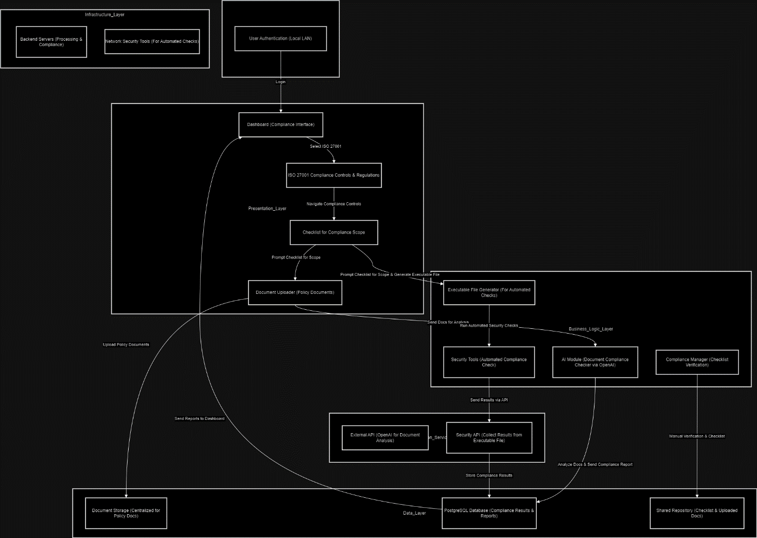

Description for High-level Architecture:
- Authentication Layer:
  - UserAuth: The user logs into the system, which is deployed locally on a LAN.
- Presentation Layer:
  - Dashboard: The main interface after authentication, where users can select ISO 27001.
  - ComplianceRules: Displays the ISO 27001 compliance controls and regulations.
  - Checklist: Prompts users for specific information related to the compliance rules (e.g., the scope of endpoints, cloud usage, etc.).
  - DocumentUploader: Allows users to upload necessary documents (e.g., contracts, NDAs) to check compliance.
- Business Logic Layer:
  - AI Module: This component sends the uploaded documents to OpenAI's API for analysis to check whether the documents comply with the compliance rule.
  - Executable File Generator: Based on the compliance rule and checklist, this component generates executable files that users can run to perform automated security checks.
  - Security Tools: These tools perform automated checks on the organization's endpoints (e.g., cloud infrastructure, firewalls, etc.).
  - Compliance Manager: If certain controls are not automated, this component assists auditors in performing manual verification and tracking through the checklist.
- Data Layer:
  - Document Storage: Stores all the uploaded policy documents.
  - Compliance Database: Stores compliance results, audit logs, and reports generated from document analysis and automated security checks.
  - Shared Repository: This contains the results of manual checks and uploaded documents for further review by auditors.
- Integration/Service Layer:
  - External API: Communicates with the OpenAI API to analyze uploaded documents for compliance.
  - Security API: Communicates with the executable file to gather the results of the automated security checks and updates the compliance status.
- Infrastructure Layer:
  - Backend Servers: Handle processing tasks such as document storage, AI analysis, and security checks.
Network Security: Manages the network-level security checks using tools like Nmap, Wireshark, etc.

Justification for the Architecture

The proposed architecture is designed with scalability, modularity, and ease of maintenance in mind, adhering to the layered architecture pattern to ensure separation of concerns across the system's components. By implementing a user authentication layer, we ensure that access to the system remains secure within a local area network, which is critical for compliance-related applications. The presentation layer serves as the interface for interaction, allowing users to navigate ISO 27001 controls and upload relevant documents, thereby making the system intuitive and accessible. The business logic layer provides flexibility by incorporating automated and manual processes, including document analysis via an external AI API (OpenAI) and executable-based security checks for infrastructure validation. This combination of AI-driven compliance verification and automated security checks improves the system's effectiveness in verifying adherence to ISO 27001 regulations.

The data layer ensures that all relevant documents, compliance reports, and audit logs are securely stored and retrievable, while the integration/service layer manages interactions with external APIs and system tools, allowing the architecture to be flexible and future-proof for integration with new APIs or tools. Finally, the infrastructure layer handles backend processing tasks, offloading resource-heavy operations from the user’s machine, thus ensuring optimal performance and scalability across different organizational setups. This architecture not only covers automated checks but also allows auditors to perform manual verification when necessary, striking a balance between automation and human oversight, which is crucial for regulatory compliance processes.

Organizational & People

Organizational
- 5.1 Policies for Information Security
- 5.3. Segregation of Duties
- 5.12 Classification of Information
- 5.13 Labelling of Information
- 5.15 Access Control
- 5.18 Access Rights
- 5.23 Information Security for use of Cloud Services

People
- 6.2 Terms and Conditions of Employment
- 6.6 Confidentiality or Non-Disclosure Agreements

  - Architectural diagram:

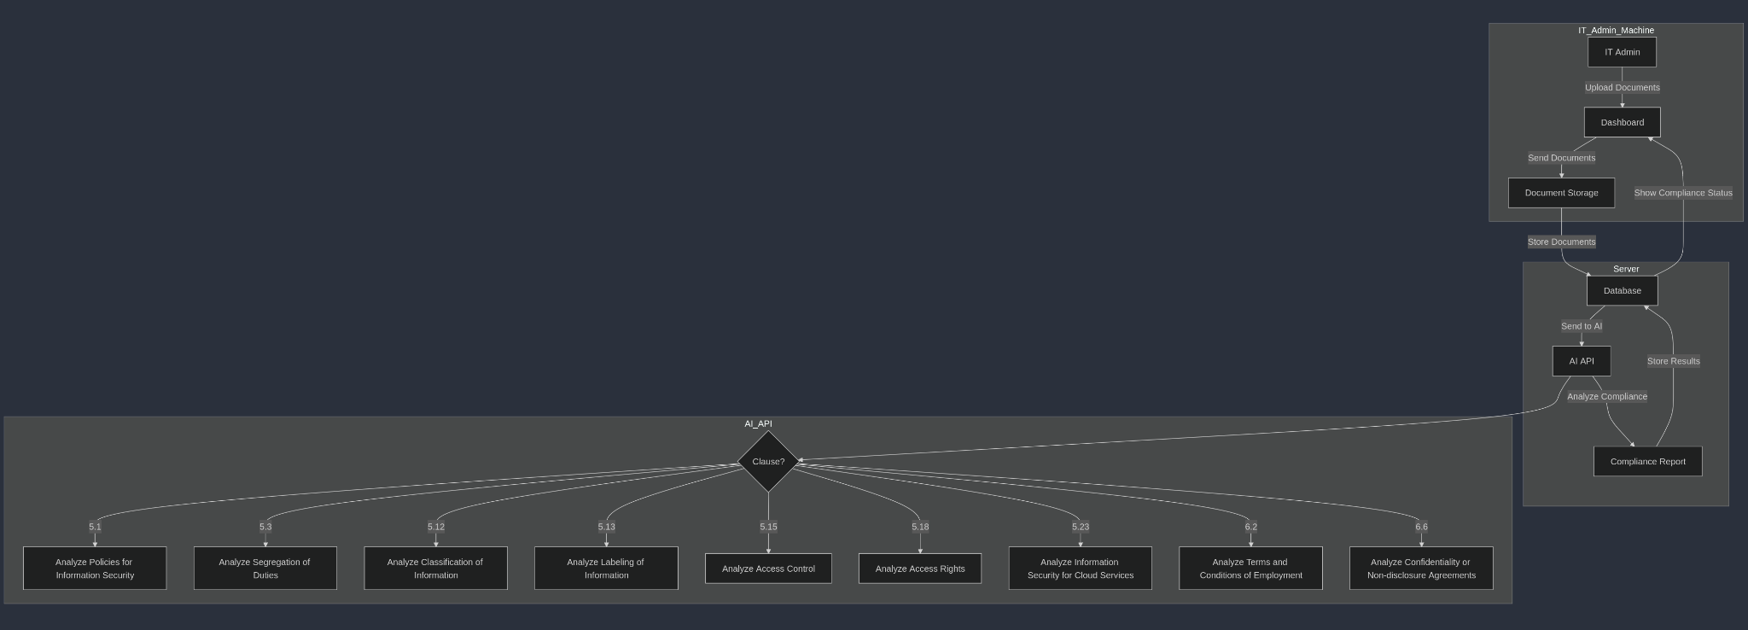

Architecture Description
- IT Admin: The admin uploads the necessary documents for each organizational or people-related clause using the dashboard.
- Dashboard: Acts as the interface through which documents are uploaded and sent for analysis. It is also where the compliance status is displayed after the analysis is complete.
- Document Storage: The uploaded documents are stored in a centralized database, which holds the files and their corresponding compliance check results.
- AI Module/External API: This is the key component where the AI (through an external API such as OpenAI) analyzes the compliance of each document. The AI is modularized, with separate modules for each clause:

  - Organizational Clauses:
    - 5.1: Policies for information security.
    - 5.3: Segregation of duties.
    - 5.12: Classification of information.
    - 5.13: Labeling of information.
    - 5.15: Access control.
    - 5.18: Access rights.
    - 5.23: Information security for use of cloud services.
  - People-Related Clauses:
    - 6.2: Terms and conditions of employment.
    - 6.6: Confidentiality or non-disclosure agreements.

- Compliance Report: After the AI processes the documents, it generates a compliance report, which is stored back in the database and shown to the IT admin on the dashboard.

Architectural Patterns Used:

- Layered Architecture: The system is clearly divided into layers:
  - The presentation layer (dashboard) where the IT admin interacts with the system, uploading documents and viewing compliance status.
  - The data layer (document storage and database) where documents and analysis results are stored.
  - The business logic layer (AI API) where compliance analysis occurs.
- Client/Server Architecture:
  - The IT Admin machine acts as the client, while the Server hosts the AI API and database, processing the documents and returning compliance results.
  - This model enables a clear separation between the user’s machine (client) and the processing logic (server), ensuring that the heavy lifting (compliance analysis) is done on the server side.
  - The client only needs to interact with the interface, simplifying the user’s experience while maintaining system performance.
- Modularized AI via External API:
  - The AI module is modularized, with separate sub-modules for each clause (e.g., Policies for Information Security, Access Control).
  - Using an external API (such as OpenAI) allows for the system to be scalable and flexible. Additional clauses can be added or updated independently as new requirements emerge, without affecting other parts of the system.

Justification for Architectural Patterns:
- Layered Architecture is essential for systems that require clear separation of concerns and maintainability. Since this system handles user input, document storage, and AI analysis, the layered structure ensures that each component can evolve independently.
- Client/Server Architecture makes sense because the client (IT Admin machine) is lightweight and simply uploads documents and retrieves results, while the server handles the more resource-intensive tasks like document storage and AI processing. This allows for better performance and scalability.
- Modularized AI via External API is useful for flexibility and future-proofing. Each clause can be treated as a separate module, and the AI can evolve independently of the rest of the system, allowing new compliance rules or clauses to be integrated smoothly.

- Technical 8.1: User endpoint security
  - Architectural diagram:

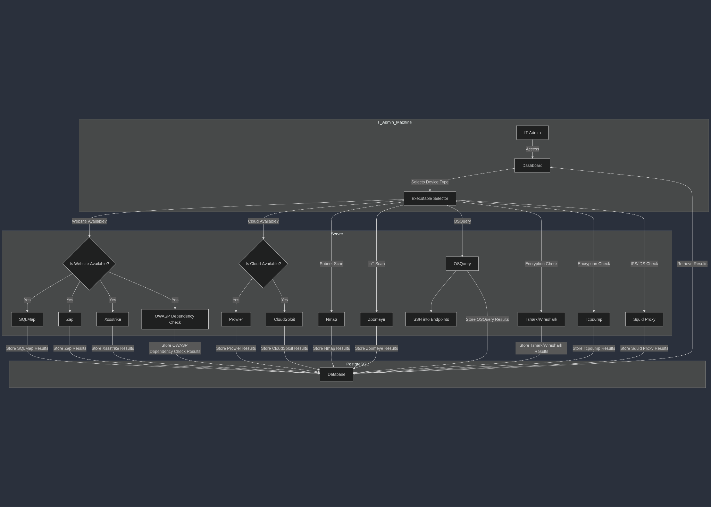

  - Architecture Details:

- IT Admin: The admin accesses the dashboard to select which user endpoint devices they want to analyze or scan based on available resources.
- Dashboard: The primary interface where the IT admin can choose between different tools depending on the availability of a website, cloud resources, or network details.
- Executable Selector: Based on the admin's input and whether a website or cloud service is available, this component triggers specific security tools.
- Tools:
  - SQLMap: If a website is available, SQLMap is used to detect SQL injection vulnerabilities.
  - Zap: Scans for vulnerabilities in web applications.
  - Xssstrike: Checks for XSS vulnerabilities.
  - OWASP Dependency-Check: Identifies vulnerable dependencies in the website.
  - Prowler: Used for cloud environment compliance checks.
  - CloudSploit: Also used to check cloud configurations and potential vulnerabilities.
  - Nmap: Scans the entire subnet for vulnerabilities.
  - Zoomeye: Used to scan IoT devices via IP address.
  - OSQuery: Gathers information from user endpoint devices through SSH and automated scripts.
  - Tshark/Wireshark: Checks for encryption and identifies IPS/IDS.
  - Tcpdump: Another tool for analyzing encryption and IPS/IDS.
  - Squid Proxy: Identifies IPS/IDS and checks for suspicious network traffic.
- PostgreSQL Database: Results from the various checks are stored here and made available for the admin to view and analyze.

Architectural Patterns Used:
- Layered Architecture: This architecture separates concerns into different layers:
  - The presentation layer is the Dashboard, where the IT admin selects and triggers scans.
  - The logic layer contains the Executable Selector, which dynamically decides which tools to run based on available resources (website, cloud, etc.).
  - The data layer includes the PostgreSQL Database, where results of various security tools are stored and retrieved.
- Client/Server Architecture:
  - The IT Admin's machine functions as the client, interacting with the dashboard and triggering scans.
  - The Server hosts the logic that runs the various security tools and stores the results. This allows for scalability and resource management since the computationally expensive tasks (like running SQLMap or Nmap) are handled on the server, leaving the client machine with lightweight operations like triggering scans and viewing results.
- Shared Repository Pattern:
  - The PostgreSQL Database acts as a shared repository where all results from different tools are stored and made accessible to the dashboard.
  - This centralization ensures that all relevant data is available in one place for analysis, enabling the IT admin to make informed decisions without needing to access each tool individually.
- Pipe & Filter:
  - Each security tool (e.g., SQLMap, Zap, Nmap, etc.) can be thought of as a filter in a pipeline, where inputs (like a website or network scan) are processed, and the results are passed along and stored in the shared database.
  - This modular setup allows individual tools to be swapped out, added, or removed with minimal impact on the overall architecture. For example, adding a new security tool would only require adding it as another filter in the pipeline.

Justification for Architectural Patterns:
- Layered Architecture ensures maintainability and scalability by dividing the system into clear layers with distinct responsibilities. This is critical for a system that handles multiple tools and data sources.
- Client/Server Architecture allows for distributed processing, with the client (admin machine) only handling lightweight tasks while the server processes heavy operations like running network scans.
- Shared Repository centralizes data storage, allowing for efficient access to results from different tools, which improves reporting and decision-making.
- Pipe & Filter enables a flexible and modular system where each tool operates independently, simplifying future updates, tool additions, or replacements.

- Architectural diagram: Technical 8.4: Access to source code

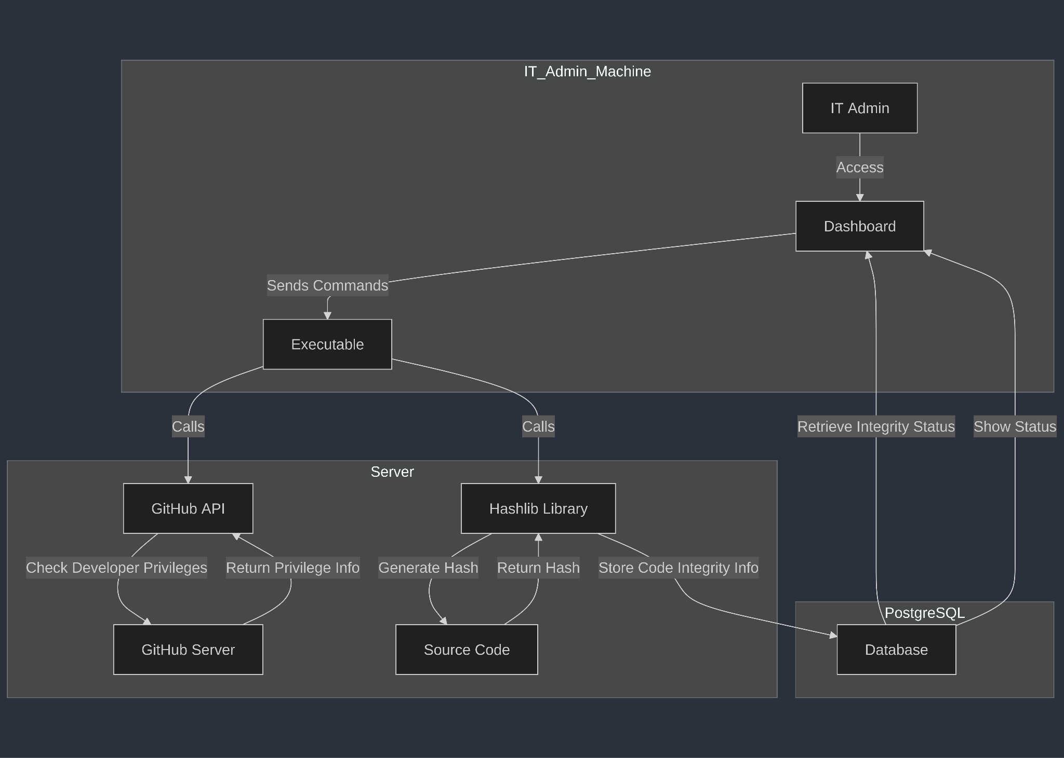

Architecture Description

IT Admin
The IT Admin accesses the online dashboard to initiate commands related to accessing and verifying the integrity of the source code.

Dashboard
This serves as the primary interface for the IT Admin. The dashboard communicates with executables to check source code access and integrity.

Executable
This component handles logic execution. It connects to the GitHub API to verify developer privileges and also calls the Hashlib library in Python to generate a hash of the source code.

GitHub API
Used to verify the privileges of the developer accessing the source code. It interacts with the GitHub server to retrieve developer information.

Hashlib Library
This Python library generates the hash of the source code, ensuring the integrity check is performed by comparing the stored hash with the current one.

PostgreSQL Database
The hash and other code integrity information are stored in a PostgreSQL database. This database can be queried to show the integrity status on the dashboard.

Architectural Patterns Used

Layered Architecture
The system is clearly divided into layers:
- The presentation layer is the Dashboard, where the IT Admin interacts with the system, sending commands to verify source code access and integrity.
- The business logic layer includes the Executable, which handles the logic for invoking the GitHub API to check developer privileges and the Hashlib library to verify source code integrity.
- The data layer consists of the PostgreSQL database, where the integrity information (hashes) is stored and retrieved for further reporting.
This layered structure ensures that changes or updates to the verification logic (e.g., updating the Hashlib library or API calls) do not affect the dashboard or data storage components, thereby enhancing maintainability.

Client/Server Architecture
- The IT Admin’s machine acts as the client, which interacts with the dashboard to send commands.
- The server hosts the logic, including the GitHub API calls and the Hashlib library to generate the hash and perform the integrity check.
This model ensures that the heavy processing (e.g., hashing source code) is handled on the server, keeping the client lightweight. It also provides scalability, as the server can manage multiple requests simultaneously from different clients.

Shared Repository Pattern
The PostgreSQL database acts as a shared repository where code integrity information is stored and retrieved. By centralizing all the code integrity checks in a single place, the system ensures that integrity reports are consistent and easily accessible through the dashboard.

Pipe & Filter
The Executable operates as a "pipe" that processes inputs (commands from the dashboard) and sends them through a series of filters:
- The GitHub API filter checks developer privileges.
- The Hashlib filter generates and compares the hash of the source code.
Each component (filter) processes specific tasks independently, ensuring modularity and allowing easy updates or replacements without affecting the overall system.

Justification for Architectural Patterns
- Layered Architecture ensures separation of concerns, enhancing maintainability and allowing independent development of the user interface, business logic, and data storage.
- Client/Server Architecture is crucial for distributed systems where the client (admin machine) triggers operations, and the server performs the heavy lifting (hash generation, API calls). It ensures scalability and efficiency, as the server can handle multiple requests.
- Shared Repository Pattern centralizes code integrity data, making it accessible across multiple components of the system, improving data consistency and reporting.
- Pipe & Filter enables a modular approach, where each component performs its task independently, allowing for flexibility in maintaining or updating individual parts of the system (e.g., updating the hashing algorithm or GitHub API).

- Architectural diagram: Technical 8.9: Configuration management
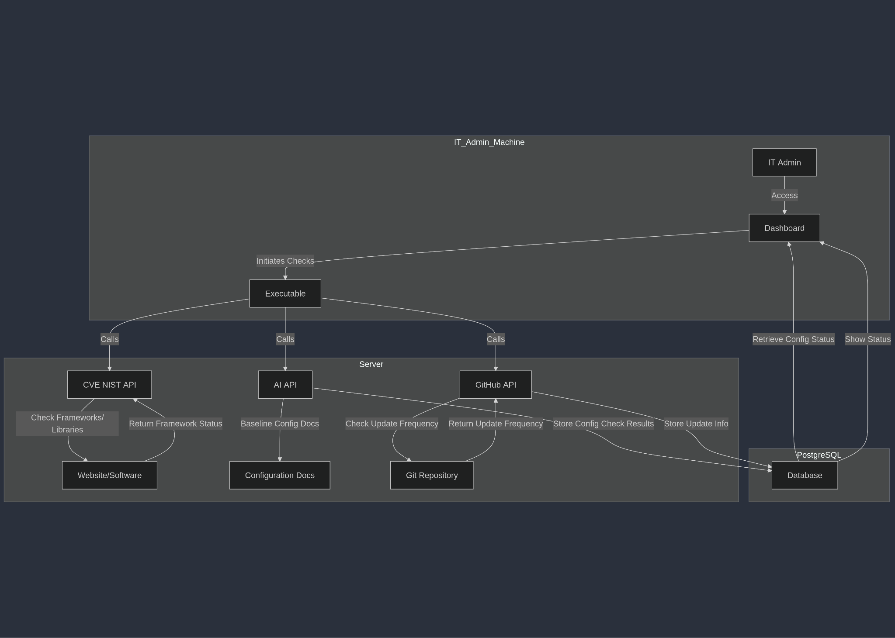

Architecture Description

IT Admin
Accesses the dashboard to initiate checks related to configuration management.

Dashboard
Serves as the interface for initiating checks on configurations, including whether outdated libraries or frameworks are being used.

Executable
Manages the logic for configuration management checks. It interacts with the CVE NIST API, AI system, and GitHub API.

CVE NIST API
This API checks the website or software for any outdated frameworks or libraries against known vulnerabilities.

AI API
An AI model that verifies the baseline configuration documents, ensuring all necessary information is included and accurate.

GitHub API
Used to verify how frequently configuration documents are updated by checking the Git repository.

PostgreSQL Database
Stores the results of the configuration checks, including document updates and framework statuses. The data is retrieved and displayed on the dashboard for the IT Admin to view.

Architectural Patterns Used

Layered Architecture
The system is structured in layers:
- The presentation layer is the Dashboard, which allows the IT Admin to initiate configuration checks and view results.
- The business logic layer consists of the Executable, which interacts with different APIs (CVE NIST, AI, and GitHub) to perform checks and gather data.
- The data layer is the PostgreSQL Database, where the results of configuration checks are stored and retrieved.

Client/Server Architecture
- The IT Admin's machine acts as the client, interacting with the system via the dashboard to trigger configuration checks.
- The Server hosts the logic (Executable and API calls) and processes the configuration checks. This allows for centralized, scalable management of configuration checks, while the client only sends requests and retrieves results.

Shared Repository Pattern
The PostgreSQL Database serves as a shared repository for storing configuration management data. The results of framework checks, configuration documents, and update frequency data are all stored centrally, allowing the dashboard to retrieve and display them when needed.

Pipe & Filter
The Executable acts as a pipeline, triggering different checks (CVE NIST API, AI API, GitHub API) and processing the results independently through filters (e.g., checking for outdated libraries, verifying configuration documents). Each tool or API acts as a "filter" in this pipeline, with the results stored in the database after processing. This modular approach enables easy updates or additions to specific checks without impacting other components.

Justification for Architectural Patterns
- Layered Architecture ensures clean separation of responsibilities, allowing each layer (user interface, business logic, and data storage) to evolve independently. This is essential for maintainability and scalability in complex systems.
- Client/Server Architecture is ideal for managing heavy operations on the server, ensuring the IT admin’s client machine remains lightweight and responsive. Centralized control over configuration checks also provides scalability.
- Shared Repository Pattern is crucial for centralizing configuration data, enabling consistency and accessibility across the entire system. It also supports versioning and traceability for configuration checks.
- Pipe & Filter architecture modularizes the different configuration checks, allowing independent processing and easy extensibility. New checks can be added to the pipeline without disrupting the existing system.

- Technical 8.20: Networks security
  - Architectural diagram:

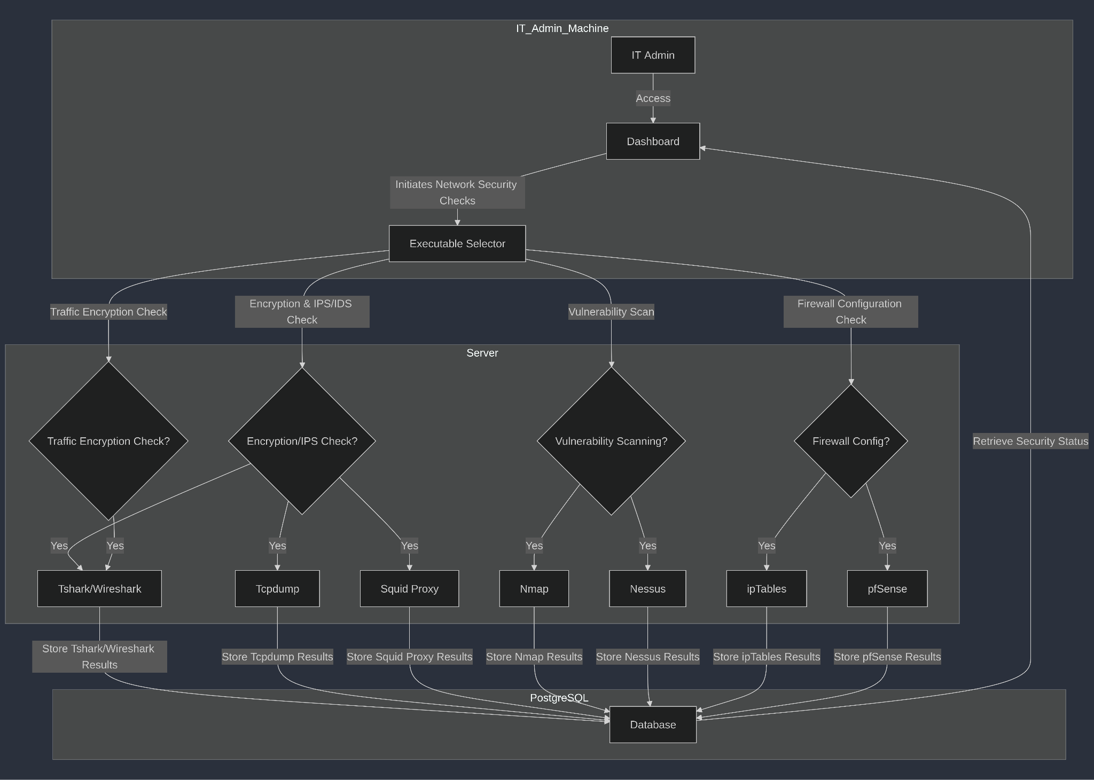

  - Architectural Details:

- IT Admin: The admin accesses the dashboard to initiate various network security checks for encryption, vulnerabilities, and firewall configurations.
- Dashboard: Serves as the interface for running different security tools based on the required check type (encryption, vulnerability scanning, firewall configuration, etc.).
- Executable Selector: Based on the admin's input, this component decides which tool should be run, and for which specific check:
  - Encryption & IPS/IDS Check: Tools like Tshark/Wireshark, Tcpdump, and Squid Proxy are run on the IT admin's PC to identify encryption protocols and IPS/IDS activity.
  - Vulnerability Scanning: Nmap and Nessus are used for network-wide scans to confirm there are no open vulnerabilities.
  - Firewall Configuration Check: Tools like ipTables and pfSense are run on individual servers to ensure firewall rules are properly configured and enforced.
  - Traffic Encryption Check: Tshark/Wireshark are used to verify that traffic is encrypted as per security protocols.
- PostgreSQL Database: All the results from the network security checks are stored in a centralized database. These results are used by the dashboard to show the current security status to the IT admin.

Architectural Patterns Used:
- Layered Architecture:
  - The system is divided into layers, ensuring separation of concerns:
    - The presentation layer is the Dashboard, where the IT admin initiates network security checks and views results.
    - The business logic layer is the Executable Selector, which determines which security tools (e.g., Tshark/Wireshark, Nmap, and ipTables) should be run based on the IT admin’s input.
    - The data layer is the PostgreSQL Database, where the results from various security checks are stored and retrieved for the dashboard.
- Client/Server Architecture:
  - The IT Admin's machine functions as the client, interacting with the dashboard to trigger network security checks.
  - The Server hosts the logic and tools that perform the security checks (e.g., Nmap, Nessus, ipTables).
- Shared Repository Pattern:
  - The PostgreSQL Database acts as a shared repository where the results of various checks are stored and retrieved. This centralization ensures that all network security data is accessible from a single source, promoting data consistency.
- Pipe & Filter:
  - Each security check (e.g., encryption check with Tshark/Wireshark, vulnerability scanning with Nmap, and firewall checks with ipTables) acts as a "filter" in a processing pipeline. The Executable Selector acts as the pipeline controller, sending data through the appropriate filters.

Justification for Architectural Patterns:
- Layered Architecture ensures clean separation of responsibilities, allowing for easy updates, maintainability, and scalability. Each layer (presentation, business logic, and data storage) can evolve independently.
- Client/Server Architecture is ideal for distributed operations, where the client (admin machine) manages lightweight interactions and the server handles the heavy processing tasks. This separation enables the system to scale and perform efficiently across multiple network environments.
- Shared Repository Pattern centralizes all the security check results, ensuring consistency and reliability. The centralized database allows for efficient retrieval and reporting of network security status.
- Pipe & Filter modularizes the system, where each security tool acts as an independent filter in the processing pipeline. This pattern allows the system to be flexible and easily extensible as new security tools or checks are introduced.

- Architectural diagram: Technical 8.21: Security of Network Services
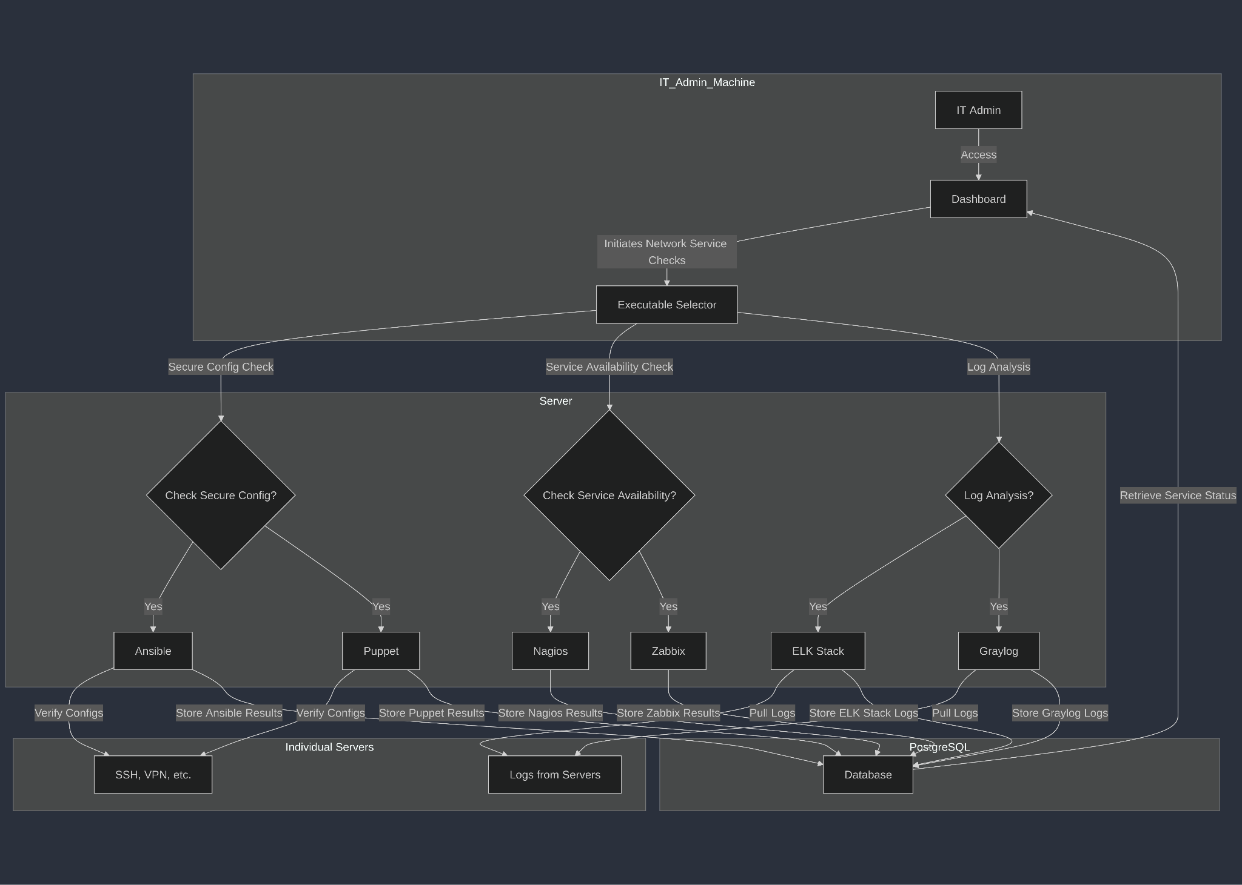

Architecture Description

IT Admin
The admin accesses the dashboard to initiate checks regarding the security and availability of network services.

Dashboard
The interface where the IT admin can start different service checks, such as secure configuration verification, service availability, and log analysis.

Executable Selector
This component allows the IT admin to select the relevant check, whether it be for secure configuration, service availability, or log analysis:
- Secure Configuration Verification: Tools like Ansible and Puppet are used to ensure network services such as SSH and VPN are securely configured. These checks are run on individual servers where the services are hosted.
- Service Availability Check: Nagios and Zabbix are used to monitor the availability and security of essential services across the network. These checks run on the IT admin's server and cover multiple services simultaneously.
- Log Analysis: The ELK Stack and Graylog tools are used for centralized log collection and analysis. These tools pull logs from individual servers and analyze them on the IT admin’s server.

Individual Servers
Hosts the specific services (SSH, VPN, etc.) where secure configurations are verified. The logs are generated and stored locally before being pulled for centralized analysis.

PostgreSQL Database
All check results, including service configurations, availability status, and log analysis, are stored here. The data is then retrieved by the dashboard to provide a summary of network service security.

Architectural Patterns Used

Layered Architecture
The system is divided into distinct layers:
- The presentation layer is the Dashboard, where the IT admin initiates network service security checks and views results.
- The business logic layer includes the Executable Selector, which determines which specific security tools (Ansible, Nagios, ELK Stack, etc.) to run based on the IT admin's input.
- The data layer consists of the PostgreSQL Database, where results from configuration checks, service availability monitoring, and log analysis are stored.

Client/Server Architecture
- The IT Admin's machine functions as the client, accessing the dashboard to initiate checks.
- The Server handles the execution of checks by running the necessary tools (e.g., Ansible, Puppet, Nagios, and ELK Stack) and processing logs. This architecture allows for better scalability, as the server takes on resource-intensive operations (like running multiple checks), while the client focuses on initiating actions and viewing results.

Shared Repository Pattern
The PostgreSQL Database serves as a shared repository for storing results from various tools. This repository provides a centralized location for storing configuration, availability, and log data, which the dashboard retrieves for analysis.

Pipe & Filter
Each security tool (Ansible, Puppet, Nagios, ELK Stack, and Graylog) acts as a "filter" in a pipeline. The Executable Selector is responsible for passing input data (commands from the admin) through these filters to perform the checks. Each tool performs its task (e.g., checking configurations, monitoring service availability) and passes the results to the database.

Justification for Architectural Patterns
- Layered Architecture provides clean separation of responsibilities, improving maintainability and scalability. Each layer can evolve independently, allowing updates or changes to one layer without affecting others.
- Client/Server Architecture enables distributed processing, where the client (admin machine) triggers checks, and the server performs the heavy lifting of running checks and analyzing logs. This pattern is crucial for efficiently managing large-scale network services across many servers.
- Shared Repository Pattern centralizes all the data related to network service security checks, ensuring consistency and facilitating efficient access and reporting. This centralization is critical for analyzing service status and logs in a unified manner.
- Pipe & Filter allows the security checks to be modular, where each tool performs its function independently. This pattern supports extensibility and flexibility, allowing new tools to be added to the pipeline as required, without impacting the existing system.

- Technical 8.23: Web filtering
  - Architectural diagram:

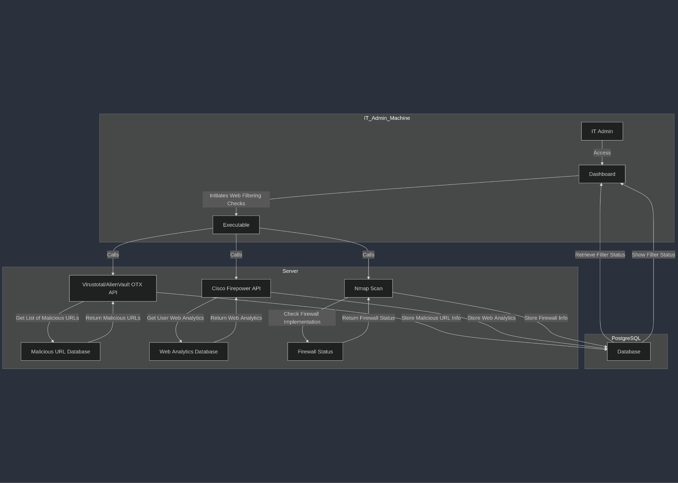

  - Architectural Details:

- IT Admin: Uses the dashboard to start web filtering checks for the company's network security.
- Dashboard: The interface where the IT admin initiates checks, including analyzing web traffic and security measures.
- Executable: Orchestrates the web filtering checks by interacting with different APIs and tools, like VirusTotal/AlienVault OTX, Cisco Firepower, and Nmap.
- Virustotal/AlienVault OTX API: These APIs are used to retrieve a list of known malicious URLs, which is then cross-referenced with the company's web traffic.
- Cisco Firepower API: Used to fetch user web analytics, including browsing patterns and potential security violations related to web filtering.
- Nmap Scan: This tool checks whether the firewall is properly implemented, ensuring that the web filtering configuration is enforced on the network.
- PostgreSQL Database: Collects and stores data from all the checks, such as malicious URLs, web analytics, and firewall status. The data is used to display the overall web filtering status on the dashboard.

Architectural Patterns Used:
- Layered Architecture:
  - The system is divided into layers:
    - The presentation layer is the Dashboard, where the IT admin initiates web filtering checks and views the results.
    - The business logic layer is the Executable, which interacts with various APIs (VirusTotal/AlienVault OTX, Cisco Firepower, and Nmap) to perform the filtering checks.
    - The data layer is the PostgreSQL Database, where the results of the checks (e.g., malicious URLs, web analytics, and firewall status) are stored and retrieved.
- Client/Server Architecture:
  - The IT Admin’s machine acts as the client, which triggers web filtering checks through the dashboard.
  - The Server performs the heavy processing, including interacting with APIs, collecting web traffic analytics, and verifying firewall implementation. This architecture ensures that resource-intensive operations are offloaded to the server, keeping the client machine responsive and lightweight.
- Shared Repository Pattern:
  - The PostgreSQL Database serves as the shared repository, storing data from multiple sources (e.g., malicious URLs, firewall status, web analytics). This centralized storage enables efficient access to the results and ensures that the data is consistent across different tools and checks.\
- Pipe & Filter:
  - The Executable functions as a pipeline, passing data through different filters (VirusTotal, Cisco Firepower, and Nmap). Each tool processes its part of the web filtering check and stores the results in the database.

Justification for Architectural Patterns:
- Layered Architecture ensures separation of concerns, allowing for better maintainability and scalability. Each layer (presentation, logic, and data storage) can evolve independently, enabling flexibility in system upgrades.
- Client/Server Architecture optimizes processing by delegating resource-intensive tasks (API calls, data analytics) to the server while allowing the client (admin machine) to trigger actions and view results. This setup is scalable and ensures efficient use of resources.
- Shared Repository Pattern centralizes all data from the different web filtering checks, enabling consistency and easy access to the data from the dashboard. This ensures all results are available in one place, simplifying analysis and reporting.
- Pipe & Filter provides modularity, where each tool (e.g., VirusTotal, Nmap) processes part of the task and returns its results. This pattern allows for easy integration of new tools and ensures that each component can be updated or replaced without affecting the rest of the system.

Architecture Description

<Give description of each subsystem in the architecture diagram above. Moreover, give description of how subsystems interact with each other>

Description below each diagram.

Justification of the Architecture

<List down pros and cons of the architecture you have defined in the context of your system. Moreover, give a justification of why this architecture is appropriate for your system. Make sure that you also discuss how this architecture helps in implementation of non-functional requirements. >

Justification below each diagram.

Tools and Technologies

<List down tools and technologies that you plan to use for development and deployment. Make sure that you mention name and version of the tools.>

Technological Stack

Technological Stack
- Web Dashboard:
  - Technology: HTML/CSS/JavaScript using a modern framework like React or Vue.js.
  - Justification:
    - Platform independence for IT admins.
    - Benefits of JavaScript frameworks: reusable components, faster rendering, etc.
    - Node.js for backend communication ensures JavaScript use on both client and server sides.
- Database:
  - Technology: PostgreSQL.
  - Justification:
    - Robust SQL compliance, ACID transactions, scalability.
    - Handles complex queries for configuration, security checks, and document storage.
    - Supports JSON for unstructured data, handles concurrency, and large data volumes.
- Executables:
  - Technology: C and/or Bash scripts wrapped in C.
  - Justification:
    - C is efficient for system-level tasks like firewall checks, network scanning, and more.
    - Bash scripts automate Unix/Linux tasks, while wrapping them in C offers advanced error handling and flexibility.
- Security Tools:
  - Technology: Nmap, Tshark/Wireshark, VirusTotal/AlienVault APIs.
  - Justification:
    - Industry-standard tools for network security and vulnerability scanning.
    - Provides modularity and ensures the system can evolve with new tools or versions.
- AI Integration:
  - Technology: External APIs (e.g., OpenAI API) for document analysis.
  - Justification:
    - Leverage state-of-the-art AI without building in-house models, ensuring scalability.
Justifications for the Stack:
- Performance: Combination of PostgreSQL, C executables, and third-party tools ensures high efficiency.
- Modularity: Clear separation of responsibilities between the dashboard, executables, and database.
- Scalability: Client-server architecture supports resource-intensive tasks.
- Security: Use of established tools like Nmap and Wireshark ensures security best practices.

Hardware Requirements

<List down the hardware requirements. This should include requirements for both development machines and deployment servers>

The hardware requirements for ACASA are categorized into two main environments: development machines and deployment servers.

Development Machines
- Processor: Intel Core i5 (8th generation or above) or AMD Ryzen 5 equivalent
- RAM: Minimum 8 GB (16 GB recommended for handling larger datasets and smoother multitasking)
- Storage: 256 GB SSD (Solid State Drive) minimum for fast read/write operations
- Graphics: Integrated graphics sufficient for general development tasks (no GPU-intensive operations required)
- Operating System: Windows 10, macOS 10.15 or later, or Linux (Ubuntu 20.04 LTS or equivalent)
- Network: Reliable internet connection for accessing external APIs (e.g., OpenAI)

Deployment Servers
- Processor: Intel Xeon E-series or AMD EPYC equivalent (multi-core processors for efficient handling of concurrent requests)
- RAM: 32 GB minimum (64 GB recommended for high concurrency and large compliance datasets)
- Storage: 1 TB SSD (expandable based on data retention needs)
- Graphics: Not required (headless server operation)
- Operating System: Linux-based (Ubuntu Server 20.04 LTS or equivalent)
- Network: High-speed and secure internet connection for API communications and client-server interactions
- Additional Requirements:
  - Backup Storage: Additional offsite or cloud storage for backup and data recovery.
  - Security Tools: Hardware-level firewall or security appliances to ensure compliance with security requirements.

Who Did What?

Name of the Team Member | Tasks done
Ammad Akram | Tools for 8.4, 8.9, 8.23; Introduction
Shabbir Kamal | Tools for 8.1, 8.20, 8.21
Rida Bilgrami | Tools for 8.2, 8.22, 8.23
Aqdas Rizvi | Architectural diagrams; Tech Stack

Review checklist

Before submission of this deliverable, the team must perform an internal review. Each team member will review one or more sections of the deliverable.

Section Title | Reviewer Name(s)
Ammad Akram | Architectural Diagrams
Shabbir Kamal | Justification and descriptions of diagrams
Rida Bilgrami | Tech stack
Aqdas Rizvi | Tools

